Ask Me Form
St. Mary School
Cultural Arts Program

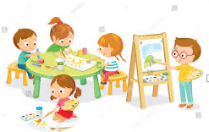

(INSERT DATE)

Today, the Cultural Arts Volunteers (insert names) visited our class.

We learned about the artist, (insert name), a modern American artist who lived from _to_(personalize).

We saw and talked about some of (insert artist’s name) paintings, included the (insert type and title of work).

Ask me about (insert fun fact(s) about the artist, his/her work and/or the presentation).

Learning about art is fun!

Click here to download the form.

