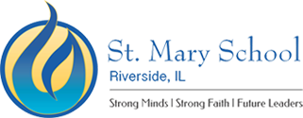

2022-23 School Calendar, At-a-Glance
Additional dates for events will be added and noted on the full school calendar

August 23 First Day of School, K-8th
24 First Day of School PK

September 5 No School, Labor Day
14 Back to School Open House, an evening for parents to meet the teachers
23 No School, Archdiocesan Faculty Professional Development Day

October 10 No School, Columbus Day

November 18 No School, Archdiocesan Faculty Professional Development Day
22 Parent-Teacher Conferences, 11:00 dismissal No LEAD
23-25 Thanksgiving Break

December 21 Christmas Prayer Service, 11:00 dismissal No LEAD
22-30 Christmas Break

January 2-6 Christmas Break
9 Classes Resume
16 No school, Martin Luther King Jr. Day
29-31 Start of Catholic Schools Week

February 1-2 Catholic Schools Week
3 No School
17 No School, Archdiocesan Faculty Professional Development Day
20 No School, Presidents’ Day

March 16 Parent-Teacher Conferences, 11:00 dismissal No LEAD
17 No School, Archdiocesan Faculty Professional Development Day

April 6-14 Easter Break

May 29 No School, Memorial Day
31 8th Grade Graduation

June 6 Kindergarten Graduation
8 Last Day of School (subject to change due to emergency days)

*First Friday of the month - 2:00 pm dismissal for full-day PreK-*8.

